Type 1 Diabetes Explained: Symptoms, Causes, Diagnosis, and How to Manage It-H1
Author : Dr. Charushila Dhole, Consultant Endocrinology

Priority | Search Volume | Keyword Intent | ASV
P1 | type 1 diabetes | informational | 60,500
P1 | type 1 diabetes symptoms | informational | 6,600
P1 | type 1 diabetes treatment | informational | 5,400
P1 | what is type 1 diabetes | informational | 5,400
P2 | type 1 diabetes causes | informational | 3,600
P2 | type 1 diabetes cure | informational | 1,600
P2 | type 1 diabetes meaning | informational | 590
P2 | type 1 diabetes test | informational | 480
P2 | medicine for type 1 diabetes | informational | 480
P2 | type 1 diabetes diagnosis | informational | 480

Title- Type 1 Diabetes: Symptoms, Causes, Treatment & Cure Guide
Description- Understand type 1 diabetes, from symptoms and causes to treatment options and potential cures. Find out how to manage and live with this chronic condition.
Slug- /what-is-type-1-diabetes
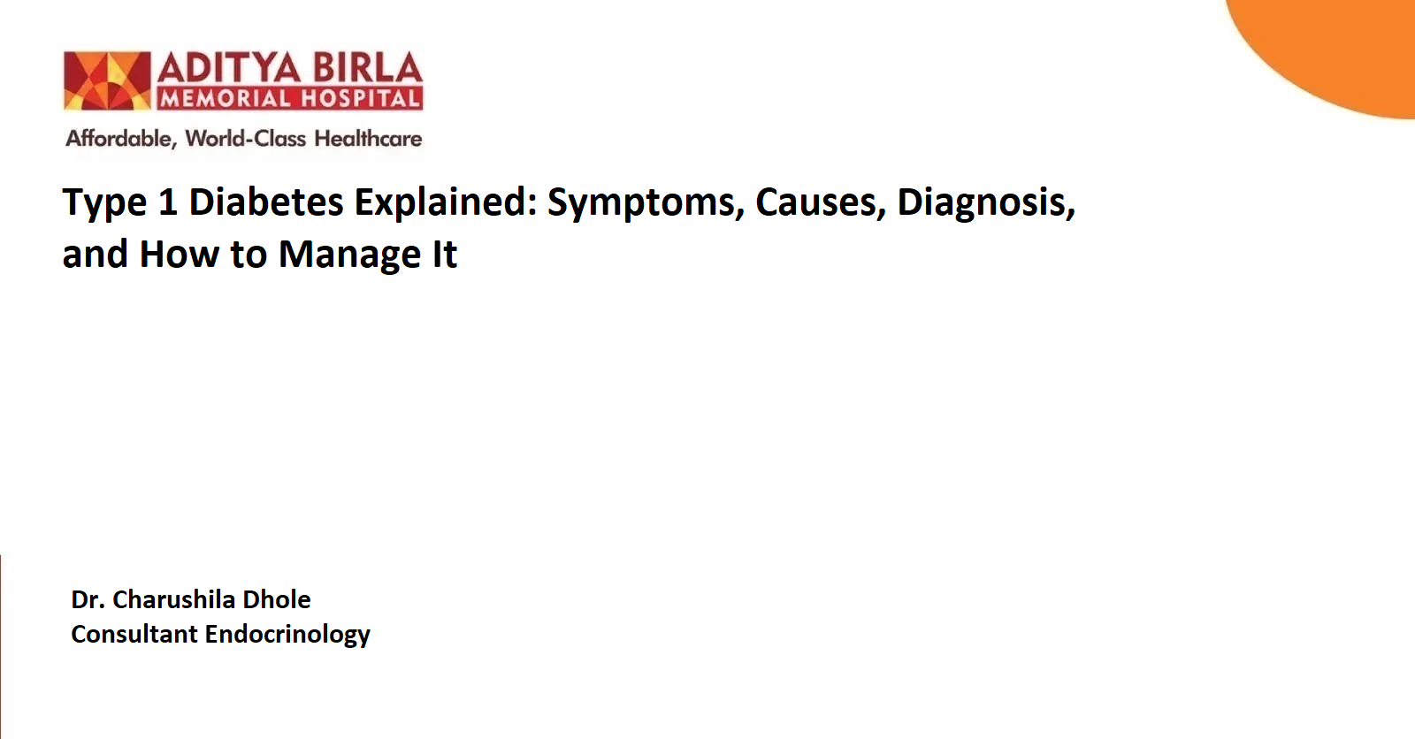

Type 1 diabetes is an autoimmune disorder where the body's immune system mistakenly targets and damages the insulin-producing cells in the pancreas, resulting in elevated blood sugar levels. Type 1 diabetes symptoms may include-
- Frequent urination
- Fatigue
- Excessive thirst
- Unintentional weight loss
Insulin therapy, regular blood sugar monitoring, and switching to a healthier diet are some of the ways you can manage type 1 diabetes. Early diagnosis and proper care ensure proper management of type 1 diabetes. In this article, we will discover the signs and symptoms, ways to manage this type of diabetes, and more.
What is Type 1 Diabetes? -H2
Type 1 diabetes is a chronic disease in which the immune system attacks the cells producing insulin in the pancreas, stopping the pancreas from making insulin. Mostly, type 1 diabetes is diagnosed in children, but some people may get diagnosed in adulthood. While the main cause of type 1 diabetes isn't fully understood, proper management, including medicine, insulin, diet, and exercise, can help manage the condition.
Type 1 Diabetes Causes -H3
The exact cause of type 1 diabetes is unknown, but genetics likely play a role. Specific genes increase the risk of you getting diagnosed with type 1 diabetes, but there are additional factors that might trigger the condition. Type 1 diabetes is generally diagnosed at a younger age, but it can develop at any age and cannot be prevented.
Type 1 Diabetes Symptoms -H3
Type 1 diabetes can cause a range of noticeable symptoms, many of which develop quickly. These symptoms include:
- Extreme thirst
- Increased hunger (even after eating)
- Dry mouth
- Frequent urination
- Unexplained weight loss
- Fatigue or weakness
- Blurry vision
- Slow healing of cuts and bruises
- Heavy, laboured breathing
- Frequent infections (including skin, urinary tract, and vaginal infections)
- Mood changes
If you notice any of these symptoms, it's important to consult a doctor immediately for early detection and treatment.
Type 1 Diabetes Risk Factors -H2
Genetics definitely play a crucial role in triggering the condition. But there are environmental factors like viral infections and others that can also lead to Type 1 diabetes.
The risk factors for type 1 diabetes aren't as clearly defined, but experts have identified some key traits that make someone more likely to develop it. These include:
- Being younger than 20 years
- Having a family member with type 1 diabetes
- Being overweight or obese
Type 1 Diabetes Diagnosis-H2
Diagnosing type 1 diabetes involves several tests to measure blood sugar levels and confirm the condition. These tests are categorised based on their purpose: confirming diabetes, identifying the type, and ruling out other conditions that may interfere with the results.
- Tests to Confirm Diabetes-H3
Here are some common type 1 diabetes tests done to confirm the condition:
- HBA1c Test-H4
This test measures average blood sugar levels over a period. It works by detecting the percentage of haemoglobin (a protein in red blood cells) coated with glucose. A result of 6.5% or higher on two separate tests indicates diabetes.
- Fasting Blood Sugar Test-H4
In this test, blood is drawn after an overnight fast. A fasting blood sugar level of 126 mg/dL or higher on two occasions indicates diabetes.
- Random Blood Sugar Test-H4
This test measures blood sugar at any random time, regardless of when you last ate. A result of 200 mg/dL or higher suggests diabetes, especially if accompanied by symptoms such as excessive thirst or frequent urination.
- Tests to Determine the Type of Diabetes-H2
It’s important to differentiate between type 1 and type 2 diabetes. Here are some common type 1 diabetes tests conducted to determine the type of diabetes:
- Autoantibody Testing-H3
Doctors check for autoantibodies, which are proteins produced by the immune system that mistakenly attack healthy cells. The presence of these autoantibodies confirms type 1 diabetes.
- Ketone Test-H3
Type 1 diabetes often causes the body to break down fat for energy, producing acids called ketones. A urine test can detect ketones, which are usually absent in type 2 diabetes.
Type 1 Diabetes Treatment Options -H2
Unlike many other health conditions, type 1 diabetes is primarily managed by you. Here are some ways to take control of your type 1 diabetes.
- Contact Your Diabetes Care Team-H3
A strong support system can make all the difference. It would help if you had a solid team of doctors and support staff to manage diabetes successfully. Here's who should be included in your diabetes care team:
- Primary care doctor: Monitors overall health and diabetes management.
- Endocrinologist: Specialises in diabetes care and insulin management.
- Registered dietitian nutritionist: Helps design a diabetes-friendly meal plan.

Your family and close friends also play a key role in providing emotional and practical support.

- Insulin Therapy-H3
Since your body no longer makes insulin, you might need to take insulin daily to control your blood sugar. Options include:
- Insulin shots: Administered using a syringe or pen.
- Insulin pump: Delivers insulin continuously through a small device.

Managing type 1 diabetes can feel overwhelming, but with the right support, you can lead a healthy, fulfilling life. You can also make some lifestyle changes to make sure you can manage type 1 diabetes effectively. Here are some changes that can help manage diabetes effectively:

- Blood Sugar Monitoring-H3
Checking your blood sugar levels is essential to stay within your target blood sugar range.
Your doctor will guide you on:
- How often do you check your levels?
- What your target blood sugar should be?

- Managing Stress-H3
Stress can raise blood sugar levels, making diabetes harder to manage. Here are some ways to cope:
- Regular exercise, such as walking or yoga.
- Relaxation techniques like meditation or deep breathing.
- Adequate sleep to recharge your body.
Discuss additional stress management strategies with your diabetes educator.

- Healthy Lifestyle Habits-H3
It's important to make changes in your lifestyle for effective long-term management. Here are some lifestyle changes you can make to deal with diabetes:
- Diet: Choose nutrient-rich foods and balance carbs with protein and fibre.
- Exercise: Stay active to improve insulin sensitivity and control blood sugar.
- Blood Pressure & Cholesterol: Manage these to prevent cardiovascular complications.

- Regular Medical Check-Ups-H3
Frequent visits with your healthcare team ensure:
- Your treatment plan is effective.
- New strategies are available if challenges arise.
Also Read - https://adityabirlahospital.com/blogs/what-is-diabetes

Type 1 Diabetes in Children-H2
Type 1 diabetes can affect children of any age, but certain factors may increase their risk. Children are more likely to develop this condition during two age ranges: 4–6 years old and 10–14 years old. A family history of type 1 diabetes also raises the likelihood of diagnosis.

Type 1 Diabetes Symptoms in Children-H2
While the symptoms of type 1 diabetes in children are similar to those in adults, there are additional signs that parents should be aware of:

- Polyuria: Urinating over 3 litres daily, exceeding normal fluid balance
- Polydipsia: Drinking excessively beyond maintaining sodium and blood levels
- Weight loss
If your child displays any of these symptoms, it’s important to consult a doctor immediately.

When to See a Doctor -H2
You should contact a doctor when you experience:
- Chest pain or pressure
- Shortness of breath
- Uncontrolled blood sugar levels
- Tingling, numbness, or pain in your feet or legs
- Worsening blurry or double vision
- Non-healing wounds or signs of infection on your feet
- Increased thirst, dry mouth, frequent urination, and fatigue
Remember that ignoring warning signs can lead to serious complications. Therefore, it's important to communicate with your healthcare provider regularly and address symptoms promptly to stay healthy.

Conclusion -H2
Type 1 diabetes is a medical condition that can be managed with diligent care. By understanding what type 1 diabetes is, you can effectively manage type 1 diabetes and contact a healthcare professional or seek emergency assistance at the right time.

References: -H2

- Kahanovitz L, Sluss PM, Russell SJ. Type 1 Diabetes – A Clinical Perspective. Physiol Behav [Internet]. Available from: https://pmc.ncbi.nlm.nih.gov/articles/PMC5606981/
- Aschner P, Horton E, Leiter LA, Munro N, Skyler JS, on behalf of the Global Partnership for Effective Diabetes Management. Practical steps to improving the management of type 1 diabetes: recommendations from the Global Partnership for Effective Diabetes Management. Int J Clin Pract [Internet]. 2010 Feb;64(3):305–315. doi: 10.1111/j.1742-1241.2009.02296.x. Available from: https://www.ncbi.nlm.nih.gov/pmc/articles/PMC2814087/

